Trinity Laban – University of Bern
Articulation Pathway
MSc/MFA Dance Science
2024-25

Trinity Laban Dance Science Programme Leader: Catherine Haber, MSc, MAS
Email: c.haber@trinitylaban.ac.uk

Programme Overview
We are very excited to begin an articulation pathway from the MAS Dance Science at the Institute of Sport Science, University of Bern to the MSc or MFA Dance Science at Trinity Laban.These pathways will provides MAS students for further study and opportunities to develop their research skills online through Trinity Laban. Below is an oevrview of the MSc/MFA Dance Science Programme at Trinity Laban. The specific articulation pathways are further outlined below.
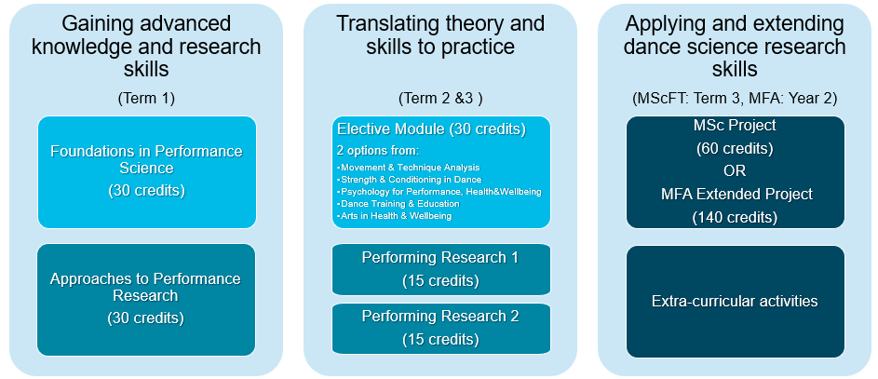
* Relevant Module descriptions can be found at the end of this document

Articulation Pathways
Programme | Term 1 | Term 2 | Term 3
MSc Dance Science | Approaches to Performance Research |  | Project
MFA Dance Science | Extended Project  Extra-curricular activities

Study Environment
The MSc/MFA Dance Science Programme takes on a blended learning approach. This means that the programme is implemented through a variety of mediums; including in-person (lecture, seminar, lab, studio or gym-based) and online sessions. Articulated UniBe students will be able to engage with all their relevant components online and therefore will not require a visa. The online sessions will be either synchronous (live) or asynchronous (pre-recorded material) on the Microsoft Teams Virtual Campus. There will be some sessions offered as hybrid, with both in-person or online options, which will further your learning autonomy and flexibility.

Academic Calendar and Contact Days
Key Academic Dates
Welcome Week: 9th September – 13th September 2024
Term 1 (Autumn): 16th September – 6th December 2024
Term 2 (Spring): 6th January 2025 – 28th March 2025
Term 3 (Summer): 21st April 2025 – 11th July 2025
Please note that MSc/MFA students continue working on their independent research projects through 26th September 2025.

Contact Days (for full-time Trinity Laban Dance Science Students)
The main contact days for the MSc/MFA Dance Science Programme are Wednesday’s and Thursday’s, with the rest of the week arranged for independent study. The main contact days may be online (synchronous) or in-person. On Tuesday afternoons, support sessions and tutorials are scheduled to support your independent learning. These sessions are delivered as hybrid sessions, so you may choose to engage in-person or online. On Friday’s, asynchronous lecture content will be made available. You may engage with the asynchronous material at your own pace, at any time from Friday to Wednesday of the following week.

UniBe MSc Pathway
Students articulating on the MSc Pathway will engage with the module Approaches to Performance Research. This module is a Research Methods module that is delivered mostly online on Wednesday’s in Term 1. Students are encouraged to join online live, though sessions are recorded for later viewing if needed. There are also asynchronous lectures and tasks students will engage with on their own time. This module prepares students to submit the research proposal and Ethics application for their Project in mid- March. Students will then conduct their Projects, with allocated supervision and seminars, starting from mid-May. Students will submit their final Projects in mid-September.

UniBe MFA Pathway
Students articulating on the MFA Pathway spend the year working on an Extended Project. The Extended Project provides students with the opportunity to conduct more extensive, in-depth research over a year. Students will submit a research proposal and Ethics application for their Extended Project in October. Students will then conduct their Extended Projects, with allocated supervision, over the year; further engaging in monthly, online research seminars and sharings. MFA students further partake in enhanced extracurriculars to gain further experience in their areas of interest. This individually guided self-study may include a range of experiences that students value in further refining their skills. This may include a practical placement, attending a conference or workshop, or engaging in independent specialisation. Students will submit their final Extended Projects in mid-September.

Annual Overview
This overview is indicative and subject to changes. The Term and Breaks are fixed in line with the Trinity Laban Academic Calendar (https://www.trinitylaban.ac.uk/study/term-dates/ ). Delivery of content may shift. The dates noted indicate the ‘week commencing’ on the noted Monday.
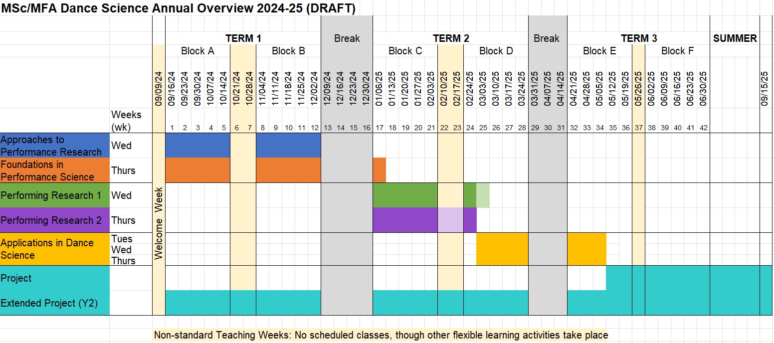

How to Apply
Please apply online by 24/9/24 (for 2024-25 academic year) via the following links:
- MSc Dance Science
- MFA Dance Science

Tips for applying:
- UCAS is an online platform for applications to conservatories. There will be some section for you to go through that will be less specific to Dance Science specifically, however you will be required to provide an answer.
- When you click the links above, you will set up an account on UCAS, which includes your interests. Dance Science may not appear, so you may select ‘Dance’.
- Under ‘Add Choice’ you will be able to select the Course you are interested in (i.e. either MSc Dance Science 801 F or MFA Dance Science 500M).
- There is no ‘Audition’ for the programme, however you will need to select any option to move forwards.
- Once you have added ‘Your choice’, you will fill in your Profile below.
- You will not need to provide an English Language Test, as you have completed your MAS studies in English.
- Under Education, enter ‘University of Bern’ manually. You will then select ‘Add qualification’ > type in/ select ‘Other International EU Qualification’. Under ‘Exam’, you will enter ‘MAS’
- Under ‘Personal statement’, please share a brief indication of your motivation to pursue the MSc or the MAS at Trinity Laban (approx. 250 words).
- You do not need to add reference details. However, if you receive an error message, you may add Andrea and Catherine, as below.
  - Academic Reference:
    - Name: Dr Andrea Schaerli
    - Occupation: MAS Dance Science Programme Leader
    - Address: University of Bern
    - Telephone Number: +41 31 684 5664
    - Email Address: andrea.schaerli@unibe.ch
    - * tick box ‘I will download the reference form to send…’, however MAS applicants do not need to download the reference form and send it to the referee.
  - Practical Reference:
    - Name: Catherine Haber
    - Occupation: MSc/MFA Dance Science Programme Leader
    - Address: Trinity Laban
    - Telephone Number: +44 20 8305 9372
    - Email Address: c.haber@trinitylaban.ac.uk
    - * tick box ‘I will download the reference form to send…’, however MAS applicants do not need to download the reference form and send it to the referee.

Fees
The tuition Fees for the MSc and MFA Pathways can be seen below:
- MSc Articulation Pathway: £3650
- MFA Articulation Pathway: £7300

Module Summaries

D70032 Approaches to Performance Research
KEY FACTS

Module: | Approaches to Performance Research
Module Code: | D70032
Delivery location: | Blended: Online and On-site (Laban Building)
UK Credits: | 30
ECTS: | 15
Level: | 7

Summary Description
This module provides a vital opportunity for the discovery, exploration, and critical enquiry of the range of research methodologies used to study dance. Bringing together perspectives of performing arts, humanities, and the scientific paradigms, this module will enable students to investigate and articulate research at Masters level within the field of dance science.
Students will gain expertise through a programme of specialist lectures, seminars, workshops and discussion groups, as well as through a portfolio of learning tasks and self-directed study. Conceptual and practical frameworks for practice-based activities, including those in the studio, performance space and the laboratory will be examined, extending students’ knowledge, and understanding of the nature of research as appropriate to dance. These opportunities will enable students to begin their development as a reflective, innovative, collaborative, and resourceful researcher.
From an introduction of philosophical frameworks and forms of scientific reasoning, we will consider the three main approaches to research – quantitative, qualitative, and mixed method approaches. With this foundation in research frameworks, we will then dive into the predominant research methodologies, such as experiments, surveys, case studies, ethnography, phenomenology, grounded theory, and action research, and their application in the field of dance science, bringing each methodology to life in practice. The essential elements of research design will be further outlined to make the connection from research question to a plan of action, introducing various methods for collecting scientific evidence, including instrument measurement, questionnaires, observation, as well as interviews and focus groups.
Beyond the specific focus on research in dance, students will gain a broader awareness of research in the performing arts, acknowledging shared research frameworks and endeavours across faculties and disciplines. The module is framed by an opening Graduate School Symposium curated in conjunction with the Faculty of Dance Post Graduate Programme Leaders, and delivered to the entire postgraduate student cohort within the Faculty of Dance and the Faculty of Music. The Graduate School Symposium sets the context for graduate level study at Trinity Laban, exemplified by contributions from both Dance Faculty and independent artist researchers. Common themes will be identified that are pertinent across artforms; these will be explored in the symposium and may be revisited through the module. This will be followed by lectures, seminars, and workshops in teaching block A and B, specific to scientific research in dance.
Through this module, students will gain a critical understanding of principal research frameworks and methodologies relevant to dance and the performing arts. With this foundational knowledge and practical experience, students will be able to critically engage with the research in the field of dance science and to design a high calibre, systematic research study of their own.

D70005 Project
KEY FACTS

Module: | Project
Module Code: | D70005
Delivery location: | Blended learning: Online and On-site (Laban Building)
UK Credits: | 60
ECTS: | 30
Level: | 7

Summary Description

The Project is an opportunity for students to pursue a selected topic of interest in dance science in some depth through an independent research project under the guidance of, and agreement with, a supervisor.
This module is characterised by a period of independent study and rigorous self-directed research, experimentation and reflection. This module encourages students to use the knowledge and understanding gained in all the other parts of the programme and employ it to the implementation of a research project. The actual body of research carried out for the project must, however, go well beyond the material covered in lectures, seminars and workshops, showing substantive depth and breadth of knowledge and skills, as well as technical command of the topic and autonomy of learning towards progressive specialisation. Topics that are not related to the taught programme in any way are likely to not be accepted by the Programme Leader or project supervisor.
This module will provide opportunities for students to experiment with ideas and methods that promote autonomy over the research process. Critical and contextual framing of the research will be required in the realisation of the ideas, which can take a variety of forms, as appropriate to the Programme of study. It also provides an opportunity for producing a dissemination output of student work relevant to the dance science research field.
Students will normally only start on this project when they have satisfactorily completed the taught modules of the programme and should only start recruitment and data collection for their project after receiving ethical approval by the Trinity Laban Ethics Committee.

Learning Outcomes

On successful completion of this module, a student will be expected to:
Knowledge and understanding
- Demonstrate systematic knowledge of current and seminal theory and research developments in selected fields as relevant to a specific research question.
- Demonstrate critical awareness and knowledge of a selected research paradigms, methodologies, methods and measurement techniques as relevant to a specific research question.
- Articulate, examine and synthesise concepts arising from research and its wider context.
- Recognise and appreciate the subjectivity and complexity surrounding embodied and experiential knowledge within dance science research.
- Implement a rigorous framework of enquiry that demonstrates a contextualised understanding of your research and its aims.

Skills
- Propose, design and implement a well justified piece of research with clear consideration of appropriate implementation and dissemination on dance settings.
- Demonstrate specific data collection and analysis competencies , and applied skills as appropriate to a specific research question.
- Work independently as well as cooperatively with faculty, peers and others, both in digital and in person contexts.
- Present and disseminate knowledge and research in a public domain following scholarly standards.

Values and attitudes
- Exercise flexibility, initiative, and personal responsibility.
- Develop as a resourceful, self-determined, reflective, and independent learner and researcher.
- Demonstrate openness and self-direction in advancing their knowledge and understanding, and in developing new skills to a high level.
- Display integrity in upholding ethical considerations as applied to dance science research and practice, including respect for codes of conduct and practice, standards, rules and responsibilities.
- Recognise and appreciate contextual and individual factors in professional contexts, in particular those related to equality, diversity and sustainability.
- Develop an appreciation of the process of research and development arising from independent inquiry.

Assessment and feedback
Overview
The assessment for this module forms the final element of the MSc Dance Science Programme. The outcomes of the Project will be twofold: (1) a journal article and (2) a 10 min public dissemination followed by 5 min of questions. (1) The 5,000 word journal article should follow the content format recommended by the Journal of Dance Medicine and Science. This includes: Abstract, key points, introduction, methods, results, discussion, implications and conclusion. A Reference List and Appendix should be included to support the article. (2) The 10 min public dissemination should take the form of one of the following: a Lecture Presentation (following International Association of Dance Medicine and Science conference presentation guidelines), or an E-poster presentation (following European College of Sport Science E-poster guidelines). The public dissemination will be followed by 5 min of questions.
Module Assessment
Assessment Component | Assessment Type | Weighting | Pass Mark | Pass/Fail
Project | A journal article (5,000 words) with a public dissemination (10 min presentation with 5 min Q & A) | 100% | 50% | No

D70010 Extended Project
KEY FACTS

Module: | Extended Project
Module Code: | D70010
Delivery location: | Blended Learning: Online and On-site (Laban Building)
UK Credits: | 140
ECTS: | 70
Level: | 7

Summary Description
The MFA Extended Project within the MFA Dance Science is an opportunity for students to engage in a major piece of research developed over an extended period of time. The Extended Project is intended to be a substantial and thoroughly researched piece of work and is characterised by rigorous self-directed research, experimentation and reflection. This module encourages students to use the knowledge and understanding gained in all the other parts of the MFA Dance Science and go substantially beyond the material covered in lectures, seminars and workshops. It also encourages MFA Dance Science students to expand the frontiers in performance science, considering dissemination and impact of their work. Topics not related to the programme in any way will not be accepted by the supervisor.
The module demands sustained enquiry and broad critical engagement, working independently over a substantial time period. The independent nature of the module requires students to be resourceful, enterprising and self-managed.
This module will provide opportunities for students to experiment with ideas and forms that promote autonomy over the research process. Critical and contextual framing of your research will be required in the realisation of ideas, which can take a variety of forms, as appropriate to MFA Dance Science. It also provides an opportunity for producing a public outlet of the work by developing resources or other outputs showing research translation and dissemination as relevant to the dance science field from research and applied perspectives.
Students will also be encouraged to engage with a range of enhanced extra-curricular activities allowing them to expand their knowledge and skills as relevant to their career interests and prospects.
Students normally only start on the Extended Project after having satisfactorily completed the taught modules of the programme. Students will normally only start recruitment and data collection for their Extended Project after ethical approval by the Trinity Laban Ethics Committee.

Learning Outcomes

On successful completion of this module, a student will be expected to be able to:
Knowledge and understanding
- Demonstrate an advanced knowledge of current and seminal theory and research developments in selected fields as relevant to a specific research question.
- Demonstrate critical awareness and advanced knowledge of a selected research paradigms, methodologies, methods and measurement techniques as relevant to a specific research question.
- Demonstrate knowledge and understanding of how to synthesise, interpret and interrogate complex ideas and concepts arising from research and its wider context.
- Recognise and appreciate the subjectivity and complexity surrounding embodied and experiential knowledge within dance science research.
- Implement a rigorous framework of enquiry that demonstrates a contextualised understanding of your research and its aims.
- Reflect on ways to enhance individual and contextual dimensions of dance practice and performance underpinned by research-informed principles and procedures.

Skills
- Propose, design and implement a robust and well justified independent piece of research with clear consideration of appropriate implementation, dissemination and impact on dance /performance settings.
- Translate theoretical knowledge into appropriate and well justified applications through the ability to analyse and deal with complex scenarios, providing informed arguments and sound judgements in the absence of complete data, and act autonomously in planning and implementing solutions at a professional or equivalent level.
- Be competent in the use of research methods, laboratory equipment, standardised measurement procedures, and advanced data analysis tools as relevant to the research question
- Work independently as well as cooperatively with faculty, peers and others, both in digital and in-person contexts.
- Present and disseminate knowledge and research in a public domain following scholarly standards and within a format suitable to specialist and general audiences.

Values and attitudes
- Exercise flexibility, initiative, and personal responsibility.
- Develop as a resourceful, self-determined, reflective, and independent learner and researcher.
- Demonstrate openness and self-direction in advancing their knowledge and understanding, and in developing new skills to a high level.
- Display integrity in upholding ethical considerations as applied to dance science research and practice, including respect for codes of conduct and practice, standards, rules and responsibilities.
- Recognise and appreciate contextual and individual factors in professional contexts, in particular those related to equality, diversity and sustainability.
- Develop an appreciation of the process of research arising from independent inquiry.

Assessment and feedback
Module Assessment
Assessment Component | Assessment Type | Weighting | Pass Mark | Pass/Fail
Ethics application | Written submission | 0% | n/a | Pass/Fail
MFA Sharing Term1 | Presentation | 0% | n/a | Pass/Fail
MFA Sharing Term 2 | Presentation | 0% | n/a | Pass/Fail
Critical Reflection (Extra-curricular Activities) | Written submission (1,000 words) | 0% | n/a | Pass/Fail
Extended Project | Written submission (12,000 words) with a public dissemination (10 min presentation with 5 min Q & A) | 100% | 50% | n/a

